Assignment 4

|  |  |
| --- | --- |
| Assignment date | 06 November 2022 |
| Student name | Harshil S |
| Student roll no | 711719104033 |
| Team ID | PNT2022TMID31586 |

# Question 1:

Pull an image from docker hub and run it on docker playground.

# Solution 1:

docker pull uifd/ui-for-docker

docker run -d -p 9000:9000 --privileged -v /var/run/docker.sock:/var/run/docker.sock uifd/ui-for- docker

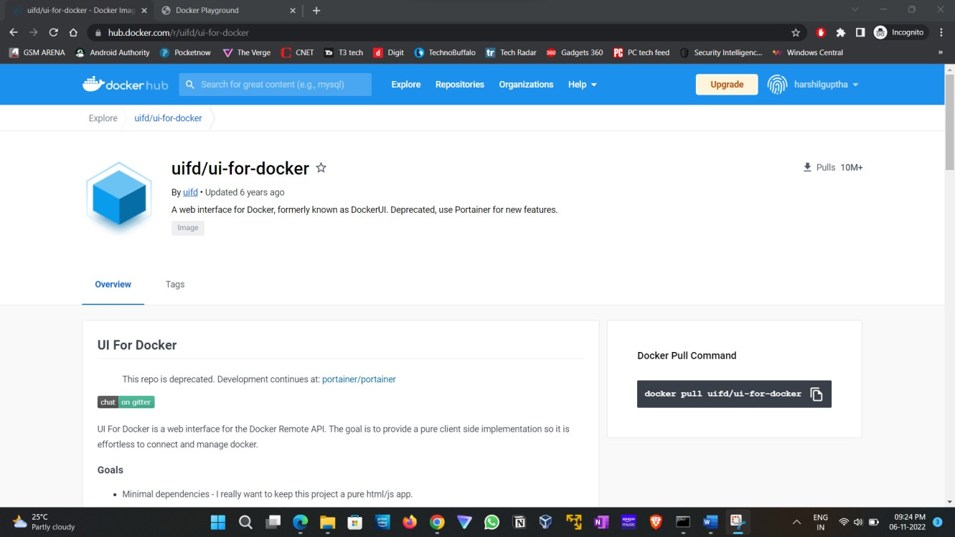

Docker playground:

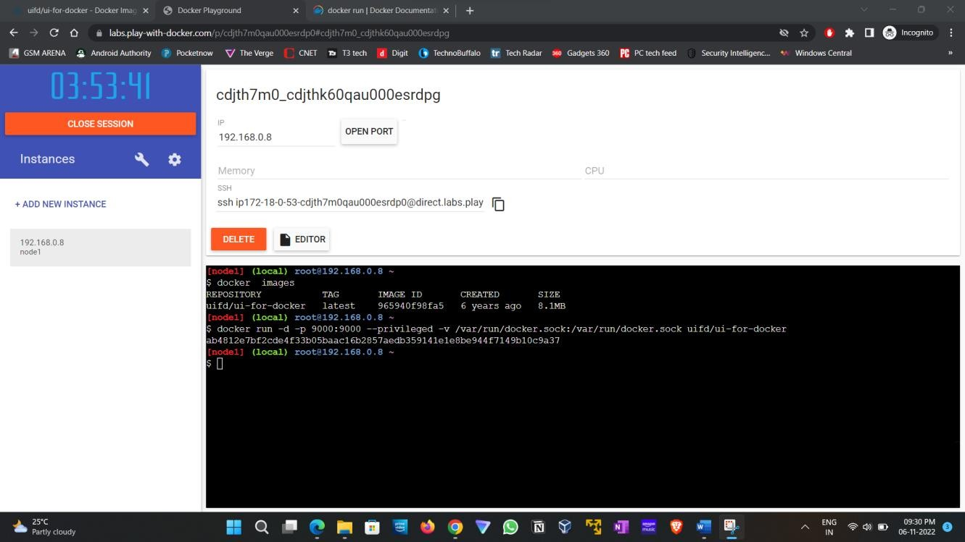

Docker UI:

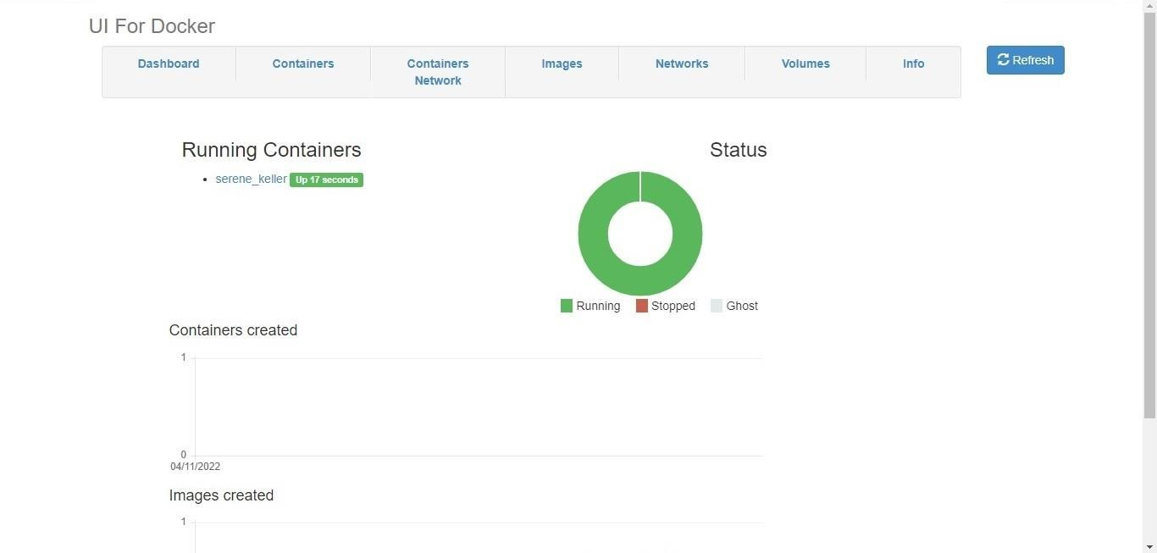

# Question 2:

Create a docker file for the job portal app or hello world app and deploy it in docker desktop app.

# Solution 2: DockerFile

**Bulid Docker image**

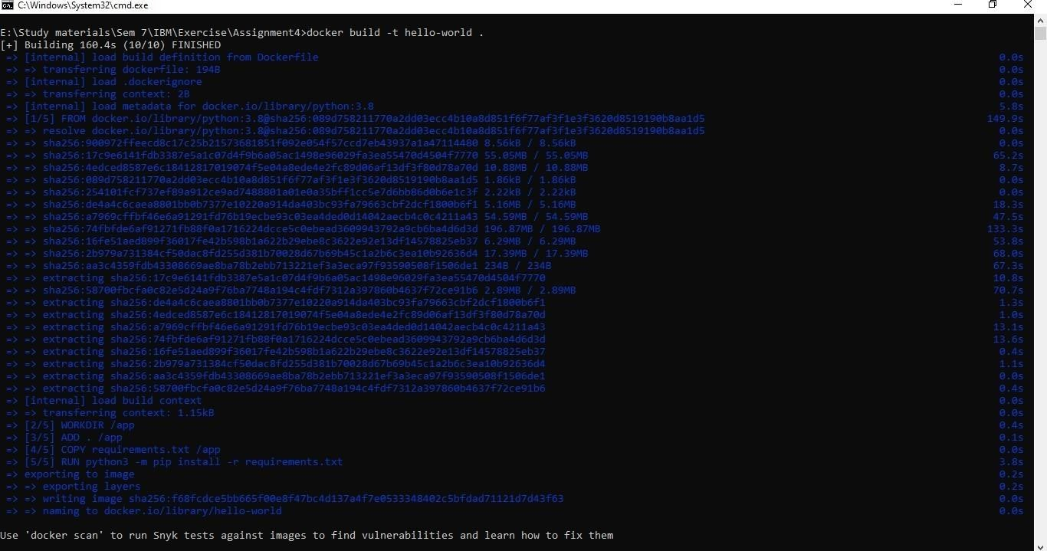

# Deploy it on Docker hub

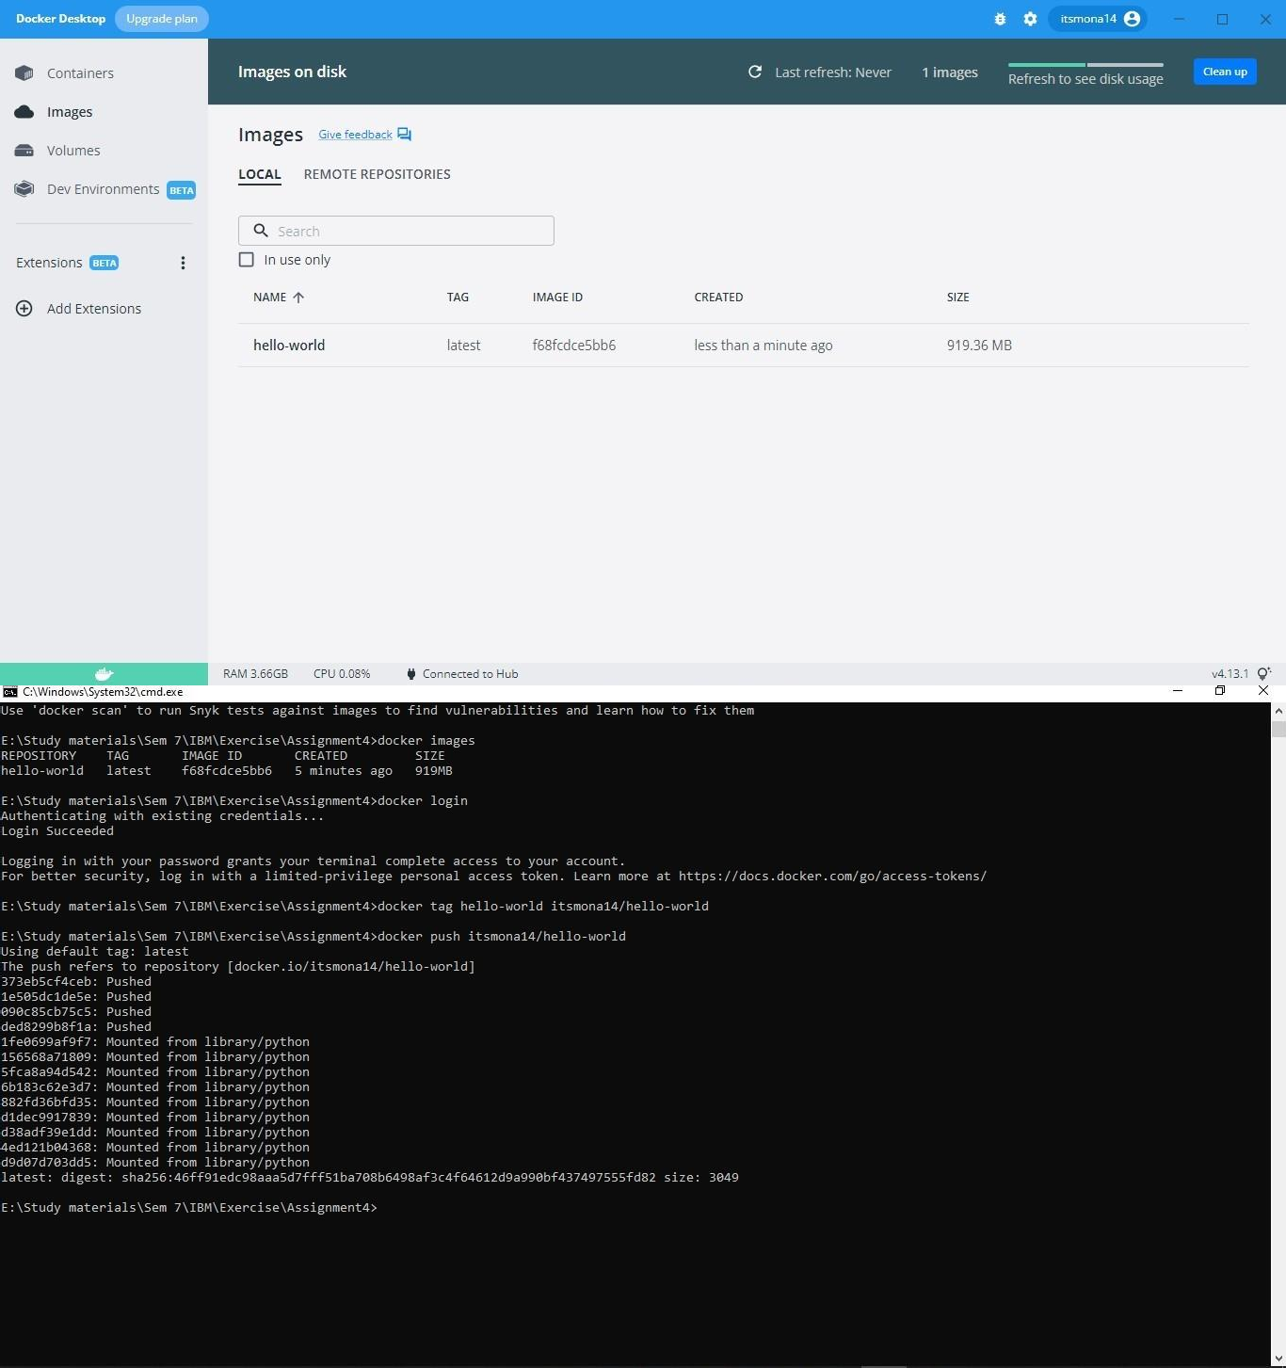

**Tested it using Docker playground**

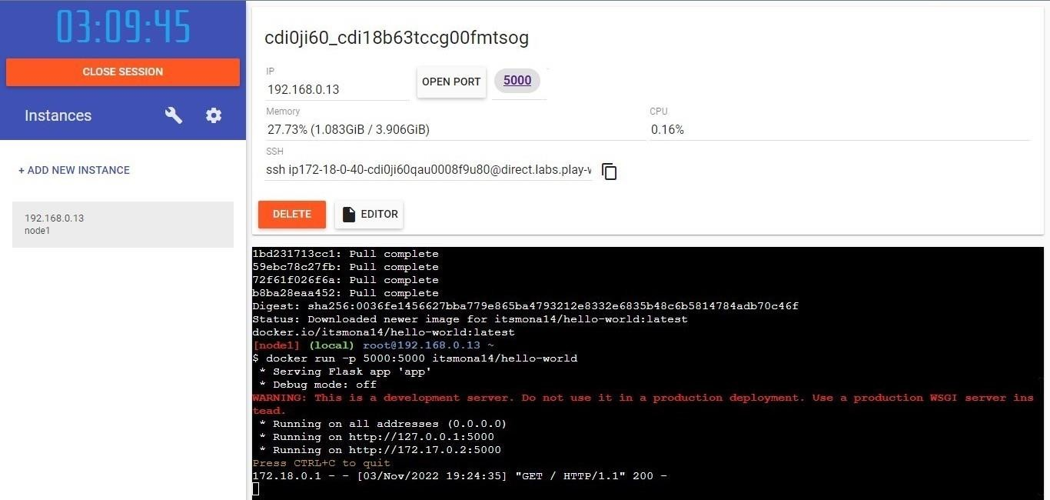

# Question 3:

Create an IBM container registry and deploy helloworld app or job portal app.

# Solution 3:

**My image link:** au.icr.io/hello-world-app/hello-world

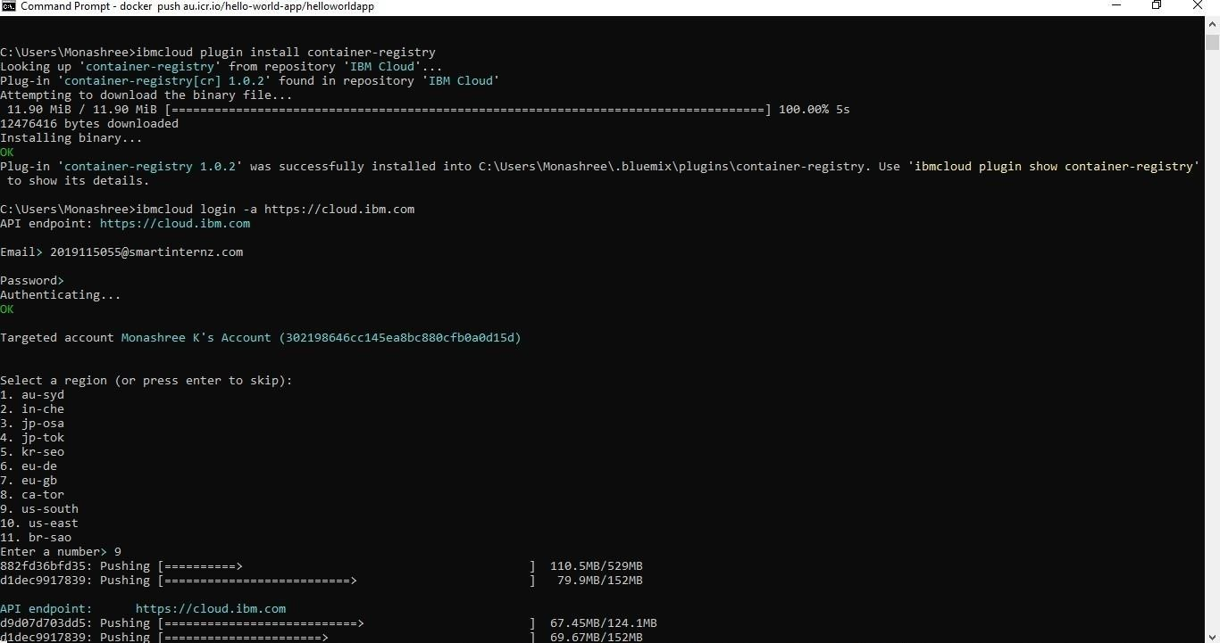

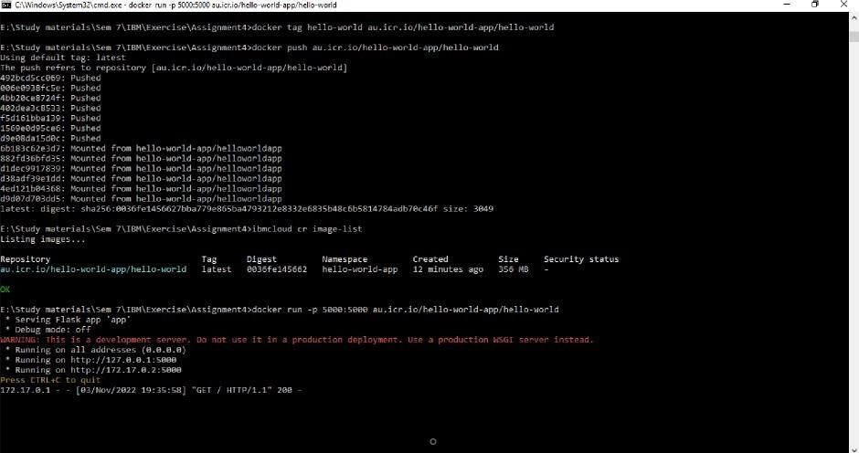

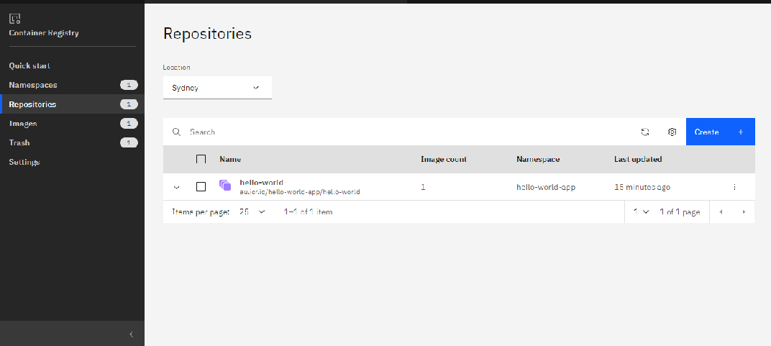

# Question 4:

Create a kubernetes cluster in IBM cloud and deploy helloworld image or jobportal image and also expose the same app to run in nodeport.

# Solution 4:

<https://raw.githubusercontent.com/itsmona14/IBM-Assignment-cloud/main/deployment.yaml>

apiVersion: v1 kind: Service metadata:

name: hello-world-deployment spec:

ports:

- port: 5000

targetPort: 5000 selector:

app: hello-world

---

apiVersion: apps/v1 kind: Deployment metadata:

name: hello-world-deployment spec:

replicas: 1 selector:

matchLabels:

app: hello-world template:

metadata: labels:

app: hello-world spec:

containers:

- name: hello-world

image: au.icr.io/hello-world-app/hello-world imagePullPolicy: Always

ports:

- containerPort: 5000

